Image sensor  (mode:4K2K ) | Type |  | Progressive scan  CMOS image sensor 1/2.5type  “ExmorR” | 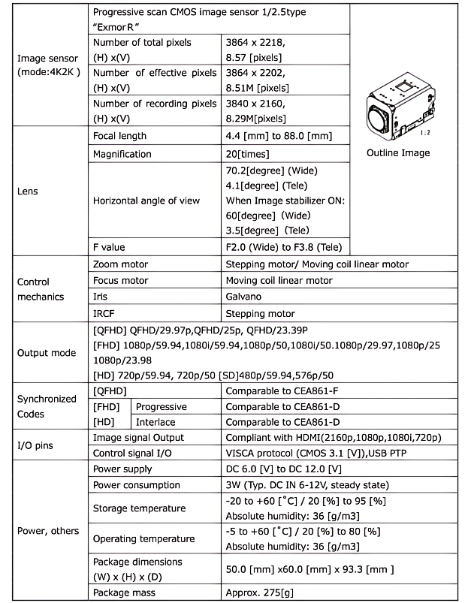  Outline Image
 | Number of total pixels  (H) x(V) |  | 3864 x 2218,  8.57 [pixels]
 | Number of effective pixels  (H) x(V) |  | 3864 x 2202,  8.51M [pixels]
 | Number of recording pixels  (H) x(V) |  | 3840 x 2160,  8.29M [pixels]
Lens | Focal Length |  | 4.4 [mm] to 88.0 [mm]
 | Magnification |  | 20[times]
 | Horizontal angle of view |  | 70.2[degree] (Wide)  4.1[degree] (Tele)  *When Image stabilizer ON:  60[degree] (Wide)  3.5[degree] (Tele)
 | F value |  | F2.0 (Wide) to F3.8 (Tele)
Control  Mechanics | Zoom motor |  | Stepping motor/ Moving coil linear motor
 | Focus motor |  | Moving coil linear motor
 | Iris |  | Galvano
 | IRCF |  | Stepping motor
Output mode | [QFHD] QFHD/29.97p, QFHD/25p, QFHD/23.39P  [FHD] 1080p/59.94, 1080i/59.94, 1080p/50, 1080i/50, 1080p/29.97, 1080p/25, 1080p/23.98  [HD] 720p/59.94, 720p/50  [SD] 480p/59.94, 576p/50
Synchronized  codes | [QFHD] |  | Comparable to CEA861-F
 | [FHD] | Progressive | Comparable to CEA861-D
 | [HD] | Interlace | Comparable to CEA861-D
I/O pins | Image signal Output |  | Compliant with HDMI(2160p,1080p,1080i,720p)
 | Control signal I/O |  | VISCA protocol (CMOS 3.1 [V]), USB PTP
Power, others | Power supply |  | DC 6.0 [V] to DC 12.0 [V]
 | Power consumption |  | 3W (Typ. DC IN 6-12V, steady state)
 | Storage temperature |  | -20 to +60 [°C] / 20 [%] to 95 [%]  Absolute humidity: 36 [a/m3]
 | Operating temperature |  | -5 to +60 [°C] / 20 [%] to 80 [%]  Absolute humidity: 36 [9/m3]
 | Package dimensions  (W) x (H) x (D) |  | 50.0 [mm]*60.0 [mm] * 93.3 [mm ]
 | Package mass |  | Approx. 275[g]


The Progressive Scan Exmor CMOS sensor----- DATA SHEET

